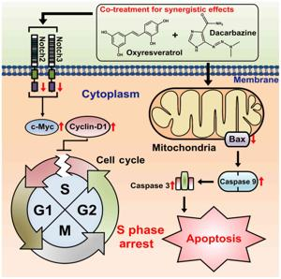
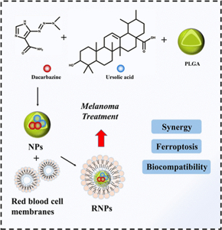
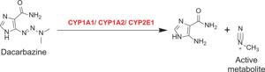
Dacarbazine is an antineoplastic (anticancer) chemotherapy drug primarily used to treat metastatic malignant melanoma and Hodgkin’s lymphoma, often as part of a multi-drug regimen such as ABVD (Adriamycin, Bleomycin, Vinblastine, Dacarbazine)125.
Mechanism of Action:
- Dacarbazine is a prodrug—it requires activation by liver enzymes (mainly cytochrome P450) to form its active metabolite, MTIC (monomethyl triazeno imidazole carboxamide)17.
- The activated form acts as an alkylating agent: it methylates DNA at the O6 and N7 positions of guanine bases, causing DNA damage and inhibiting DNA, RNA, and protein synthesis, which triggers cell death, especially in rapidly dividing cells156.
- It is cell-cycle nonspecific, meaning it is effective throughout all phases of the cell cycle78.
Major Clinical Uses:
- Metastatic melanoma (main US and international approval)125
- Hodgkin's lymphoma (often in combination chemotherapy such as ABVD)125
- Other uses: soft tissue sarcomas, neuroblastoma, medullary thyroid cancer, rhabdomyosarcoma (uses may vary by country and institution)579
Administration and Important Precautions:
- Given by intravenous injection only; not administered orally due to poor and variable absorption67.
- Like other alkylators, risk of severe local tissue irritation or necrosis if the drug extravasates (leaks outside the vein)56.
- Dosage adjustment may be needed for patients with liver or renal dysfunction7.
- Should be administered and monitored by experienced professionals due to the risk of tissue damage at the injection site and other adverse effects56.
Side Effects:
- Common: nausea, vomiting, loss of appetite, low white blood cell counts, low platelets156
- Serious: liver toxicity, severe allergic reactions, risk of tissue necrosis at injection site
- Unknown safety in pregnancy; generally avoided unless benefits outweigh risks15.
Notable Facts:
- Dacarbazine is included on the World Health Organization List of Essential Medicines due to its established role in cancer therapy1.
- Structurally, it is an imidazole carboxamide and a synthetic analog of purine precursors7.
If information about specific protocols or less common uses is required, let me know.
- https://en.wikipedia.org/wiki/Dacarbazine
- https://go.drugbank.com/drugs/DB00851
- https://synapse.patsnap.com/article/what-is-the-mechanism-of-dacarbazine
- https://www.ncbi.nlm.nih.gov/books/NBK548913/
- https://www.tfhd.com/cancer-center/drug-dictionary/dtic-dome/
- https://www.oncolink.org/cancer-treatment/oncolink-rx/dacarbazine-dtic-dtic-dome-r
- http://www.bccancer.bc.ca/drug-database-site/Drug%20Index/Dacarbazine_monograph_1June2013_formatted.pdf
- https://www.sciencedirect.com/topics/neuroscience/dacarbazine
- https://www.pediatriconcall.com/drugs/dacarbazine/458
- https://www.sciencedirect.com/topics/pharmacology-toxicology-and-pharmaceutical-science/dacarbazine

